**IOT BASED E-VEHCILE BATTERY OPTIMIZATION**

**BLOCK DIAGRAM**

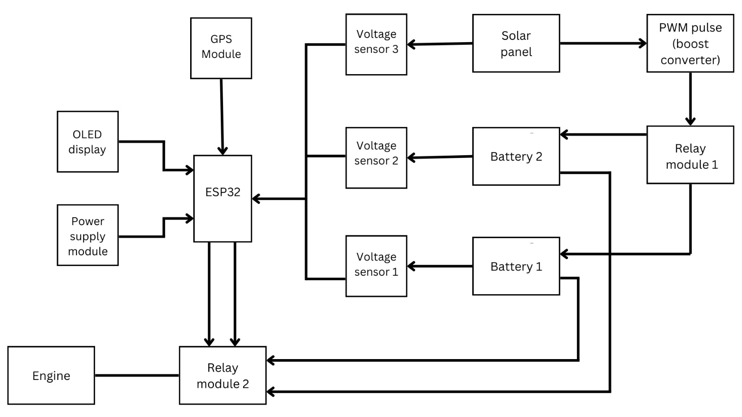

**PROTOTYPE**

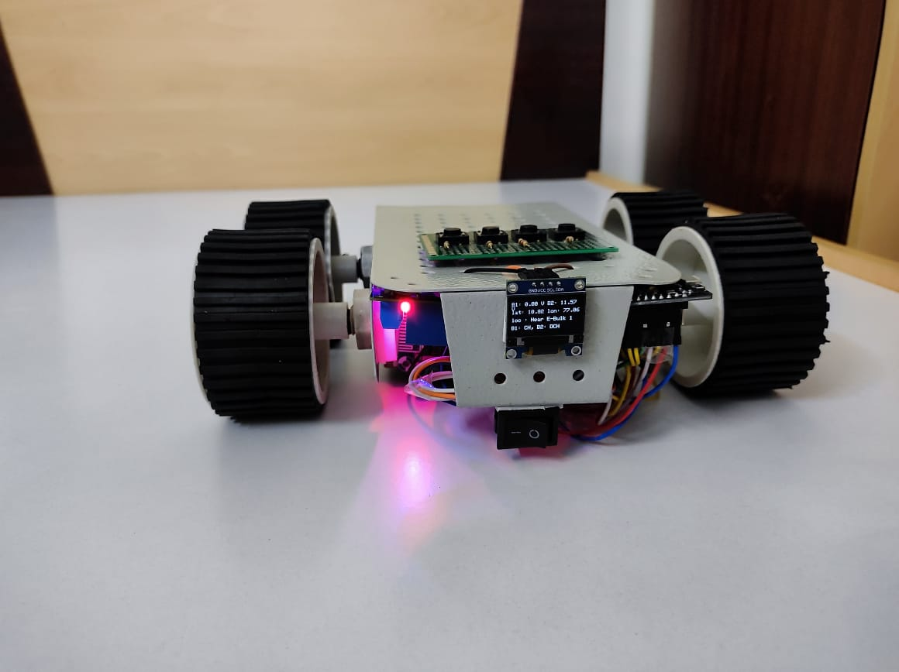

HARDWARE MODEL

**SOFTWARE**

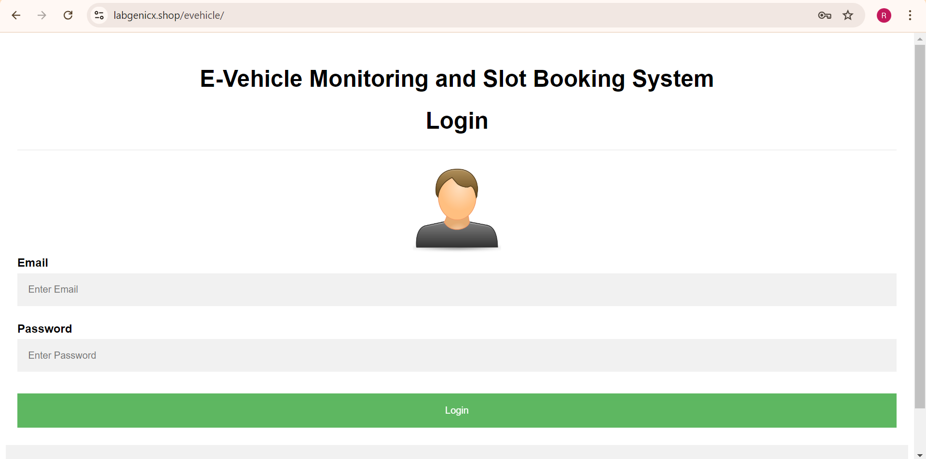

USER AUTHENTICATION

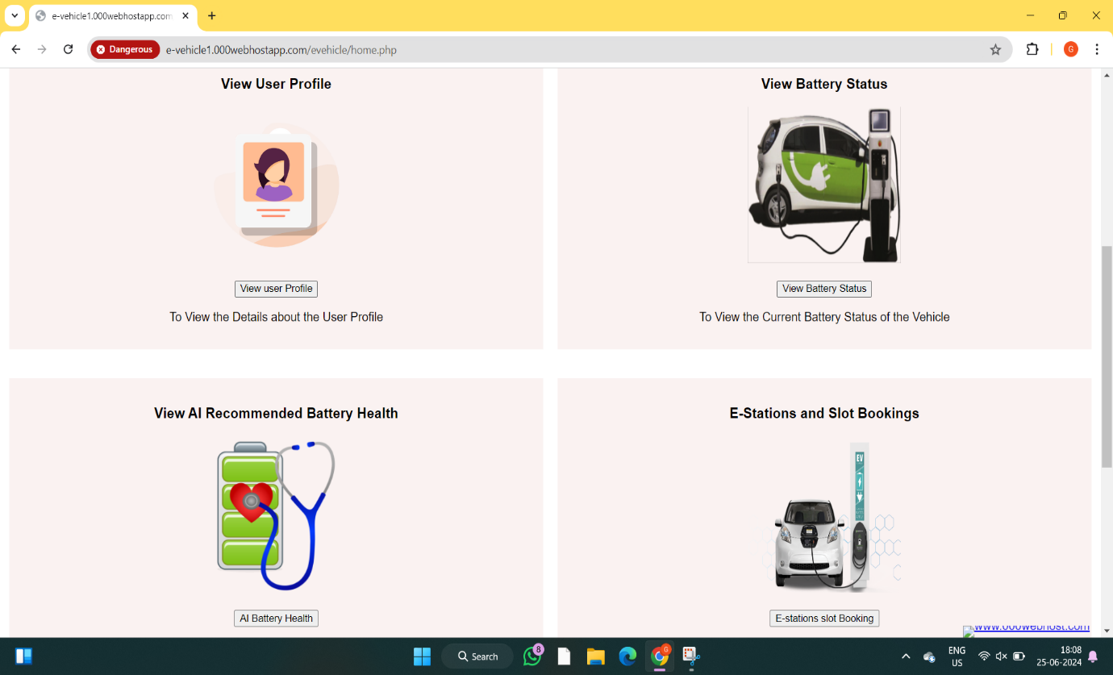

USER DASHBOARD

BATTERY MONITORING

E-STATIONS LOCATING

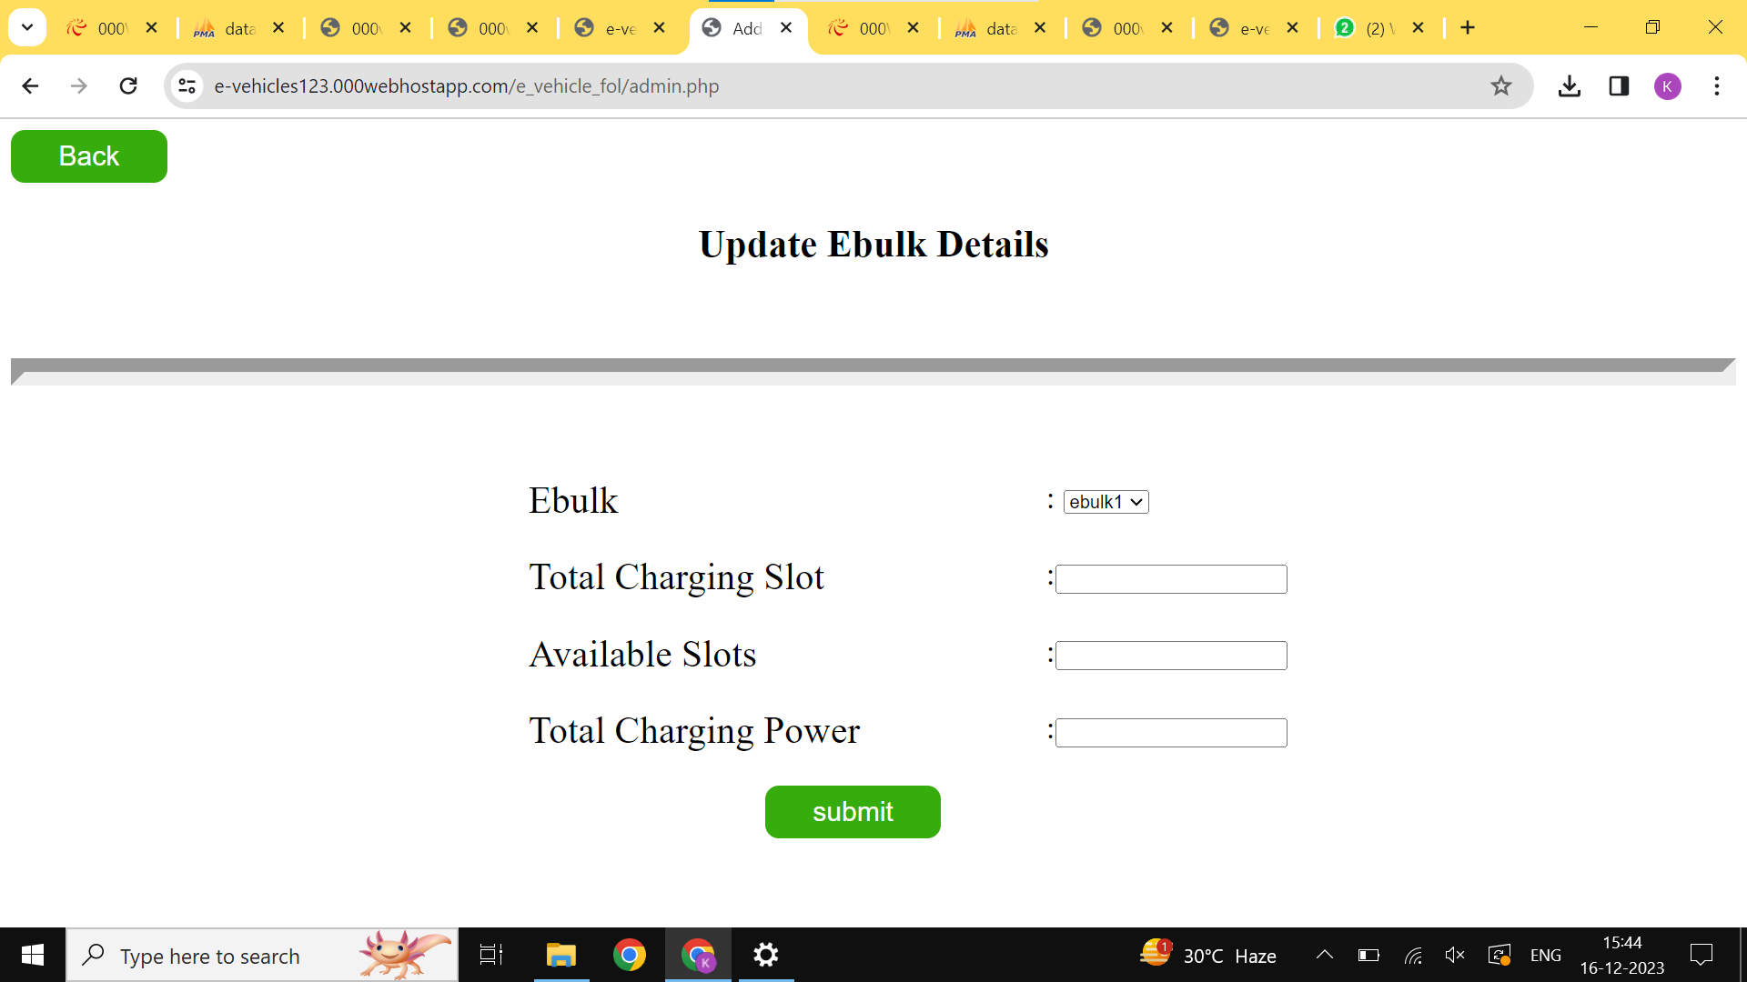

E-STATION SLOT AVAILABILITY UPDATE PAGE

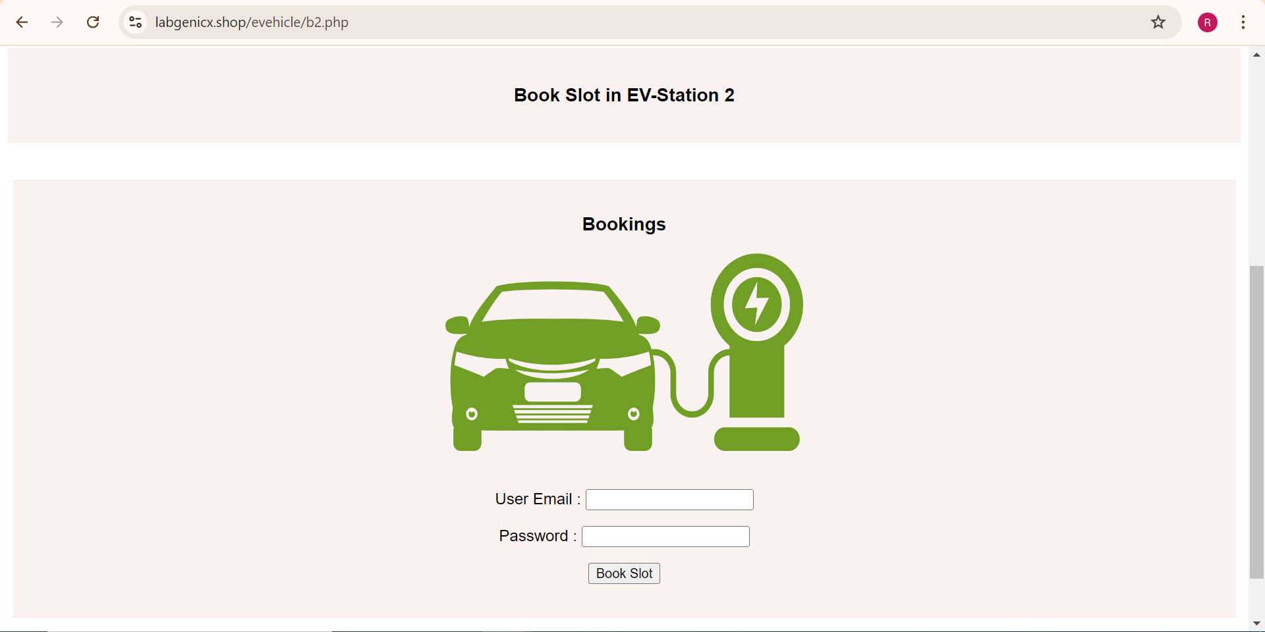

E-STATIONS SLOTS BOOKING

USER DASHBOARD

EV CHATBOT